Resource sheet 6.1: Who can give me a hand?

Who people went to for Who I can go to for help:
help in Kaiyai girl:
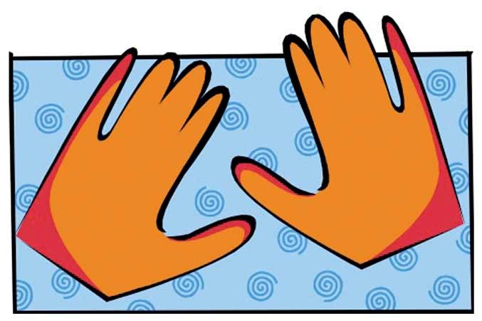

Take home message: I know people who will give me a hand and help me with any problems. I will keep asking until I get some help.

